Portfolio Initial Flow structure (changes will be made)
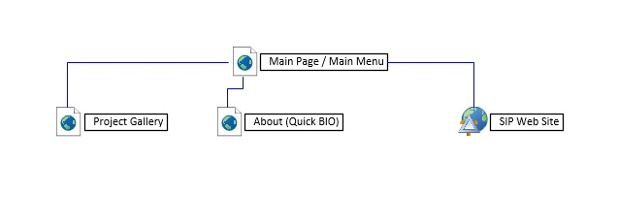
Outline of current Ideas
- Section: Algorithms
  - Search and sort benchmark
    - CSC313O ArraySearch, CSC280O SortGUI
  - Encryption
    - CSC380O AESCipherKey
- Sections: Machines
  - Processing and command environments
    - CSC275O Processor, CSC313O Client-Server Systems, CSC313O MyShell
- Sections: Artificial Life
  - Artificial Life in environments
    - CSC330O Attraction AL, CSC360O Flocking
- Sections: Games and GUI
  - Dynamic game components
    - CSC262O Space Mines, CSC318O Maze Game
  - GUI
    - CSC330O TechSavvy Shopper
- Sections: Content Development Methods
  - Web Site development tools
    - SIP Project Super Glyph

SIP Project Super Glyph : Dynamic Instant content for rapid site development
- Instant content retriever and handler for rapid web site development. Retrieve content from RSS feeds, Blogger and JSON sources like Twitter, Google Search for displaying from a web site application.
CSC330O TechSavvy Shopper : Quick listing creation and completion tool for mobile devices
- Shopping list/ToDo list for Android in Java with Agile development documents. Custom activity screens, Lists and views designed to swiftly access, create and update ‘todo’ lists.
CSC330O Attraction AL : Artificial Life environment where cell members try to attain the best possible position.
- Artificial life app loosely based on cellular automaton with Agile documents written in Visual Studio C# with Xamarin (Cross-Platform Development Tool) for Android. Cell members try to locate the best possible position within their sight and move towards it until they are in the best possible position or cannot move.
CSC318O Maze Game : Dynamic generating map adventure that changes with each game
- Dynamic map generating game written in Visual Studio C#. The map is auto-generated with each new phase and checked to make sure every spot on the board is accessible by the player.
CSC262O Space Mines : Game demonstrates graphic draw, resize and user interactivity.
- Dynamic board of possible mines. Click three bombs and you lose, uncover all the safe spots and win.
CSC313O Server : Sockets custom Client Server
- Threaded and multitasking, the server accepts custom client requests and delivers via TCP/IP sockets.
CSC313O MyShell : Custom command prompt utility.
- Custom shell / command line utility written in Visual Studio C#.
CSC313O ArraySearch : Benchmark tool for search routines (includes actual search algorithms)
- Search algorithm benchmark test. Brute search versus Index Search.
CSC280O SortGUI : Benchmark tool for sort routines (includes actual sort algorithms).
- Sort algorithm benchmark test. Quick Sort versus Index Sort.
CSC275O Processor : Assembly code processor, runs code programs.
- Assembly Code processor written in Visual Studio C++. Code machine reads and executes assembly code instructions.
CSC380O AESCipherKey : Example of AES Encryption processes
- AES Encryption algorithm processes encryption in stages written in Visual Studio C#.
CSC360O Flocking : Artificial life each member of the flock maintains proximity with the flock as they migrate.
- Artificial Life routine flocking routine designed to migrate a flock across the screen to a target. Flock individuals avoid objects in their path yet stay together while trying to reach their target.

